DEVOPS WEEK-01 ASSIGNMENT
1)Files & Directories:
- Create directory /home/devops_project
- Inside it, create 2 files: plan.txt and network_report.txt
- Copy plan.txt to /templates and delete the original
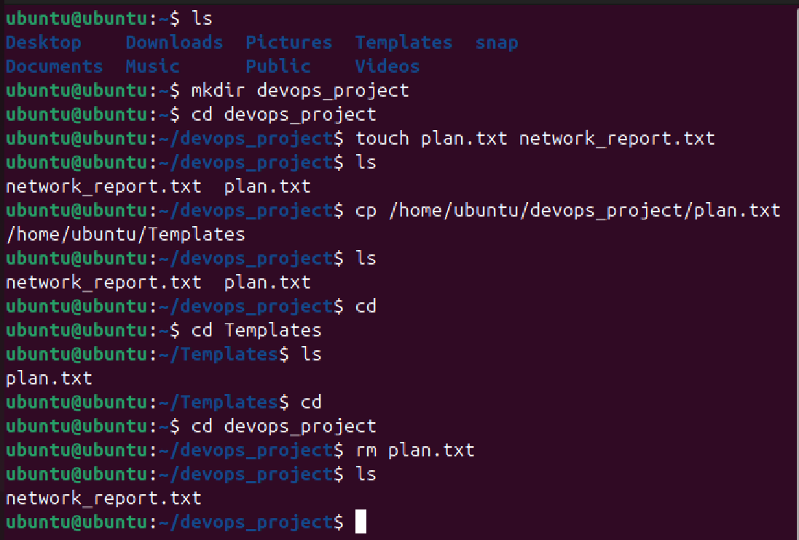

2)Users & Permissions:
- Create a user devstudent
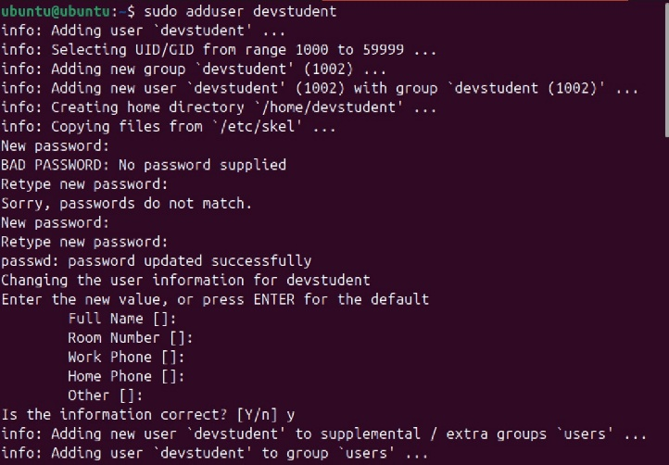
- Create a group devops_team
- Add devstudent to devops_team
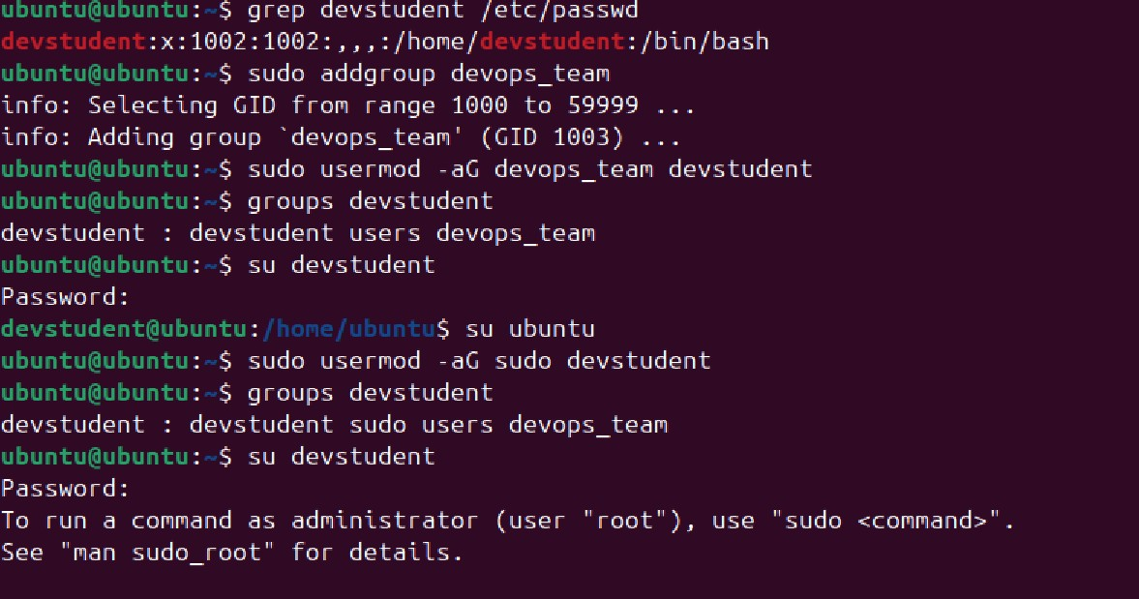

- Create a file secrets.txt: -
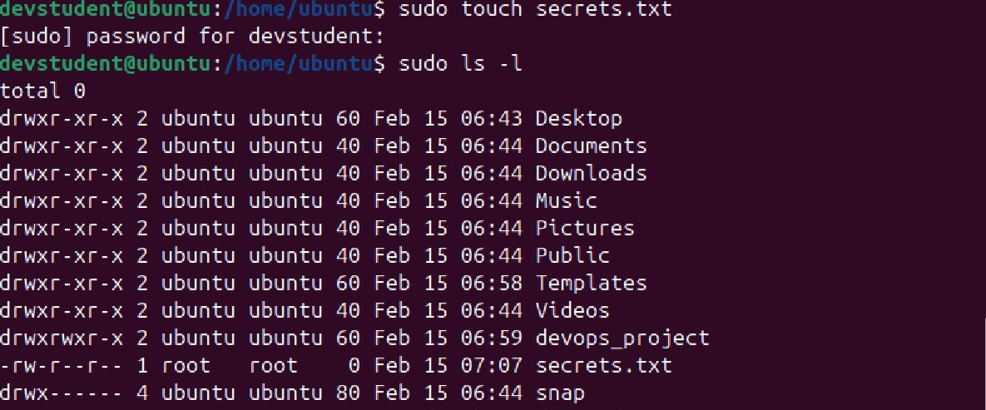
- Change its owner to devstudent
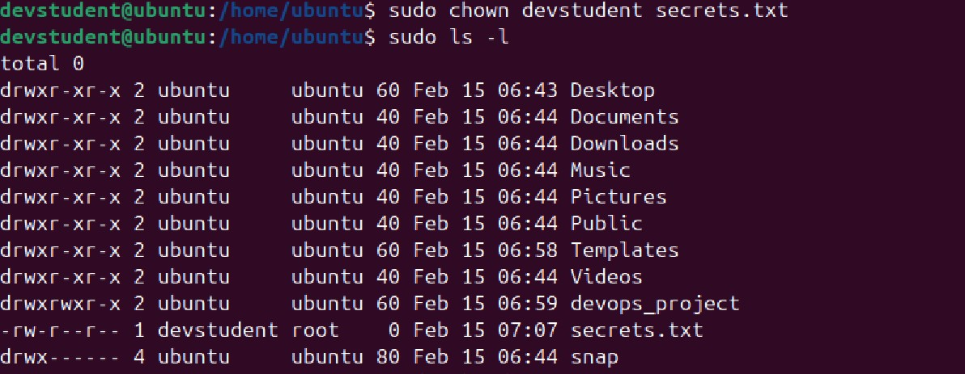
- Set permissions so only owner can read/write
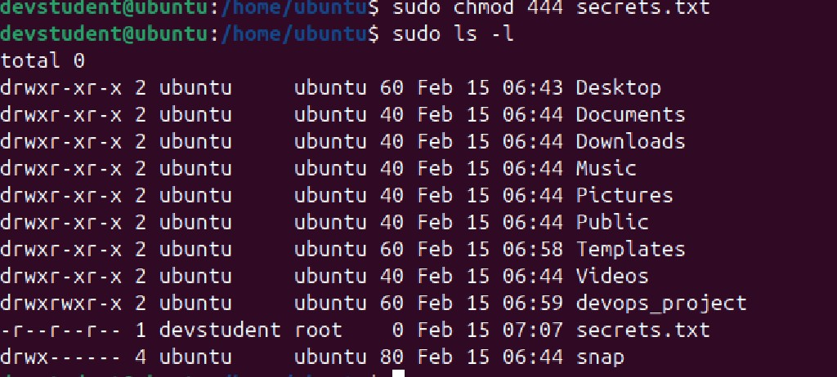

3)File Compression:
- Download a sample.log file from internet or create dummy one using echo
- Compress it using gzip and tar
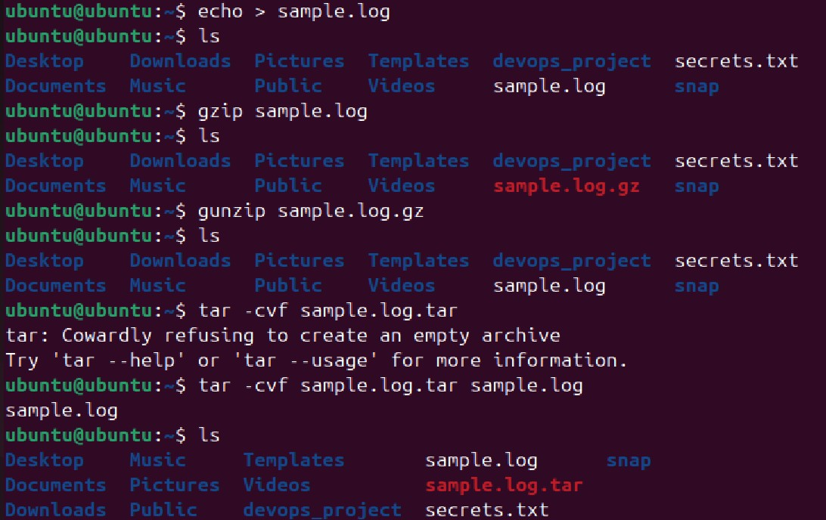

4)Package Management:
- Curl Info, Installation and Version: -
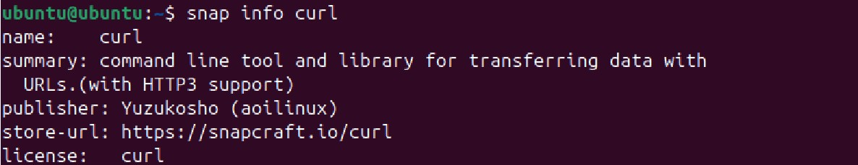
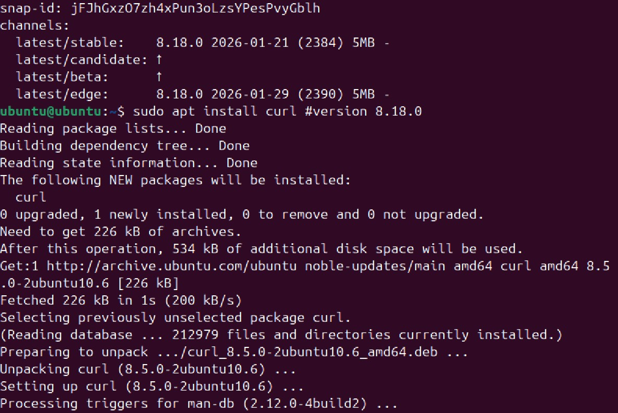
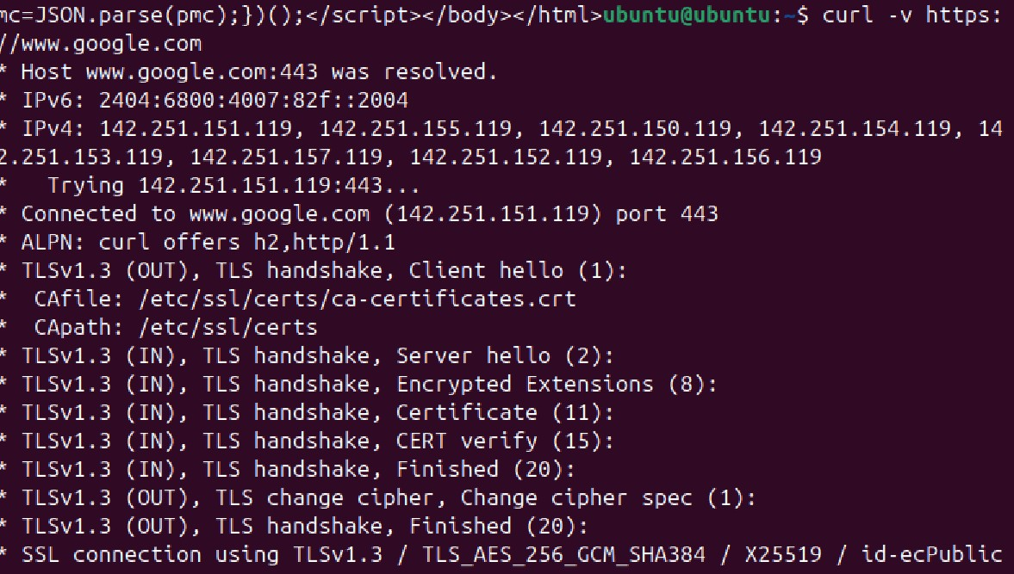
- htop Installation and Version: -
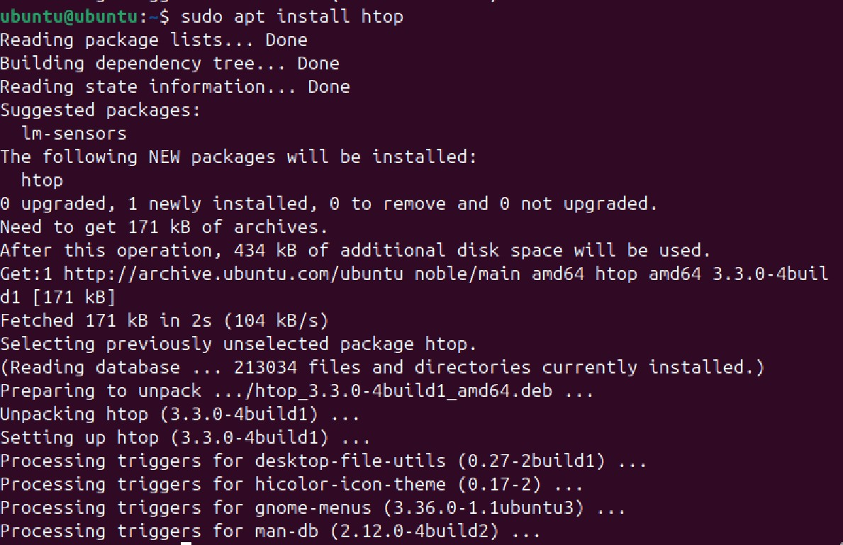

- net-tools Installation and Version: -

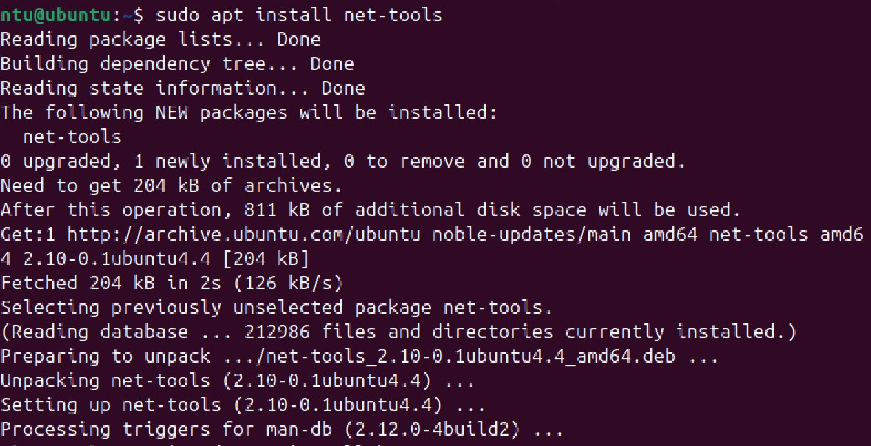

5)Run and shortly explain outputs of the following commands:
- ip a or ifconfig:-

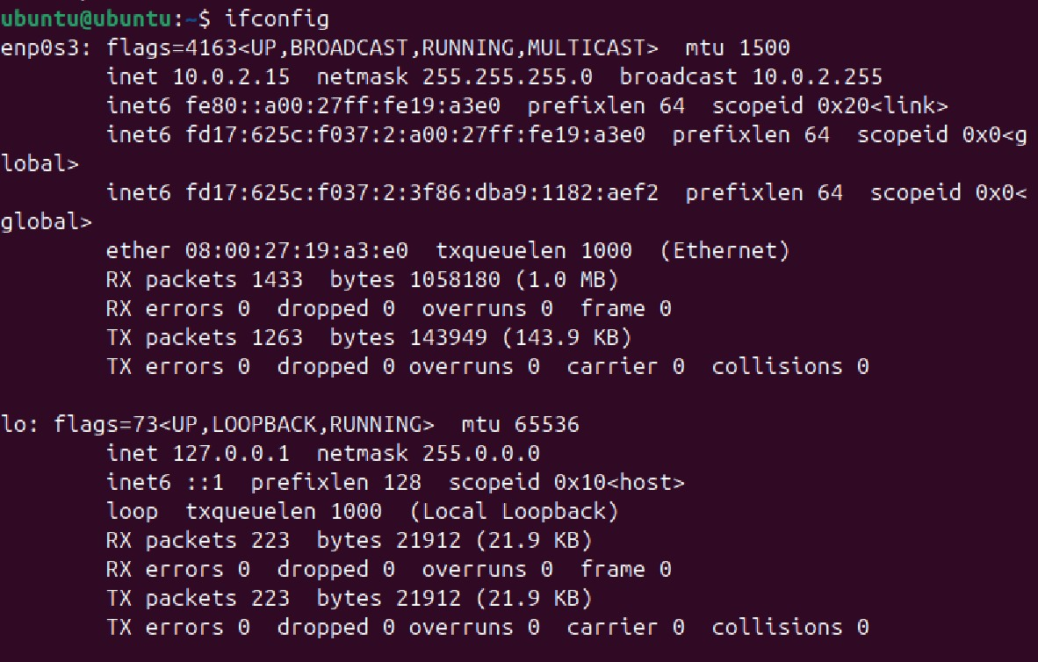
This ifconfig command is used to check IP address, Machine name(enp0s3) and other info of the system.
- ping google.com -c 4 : -

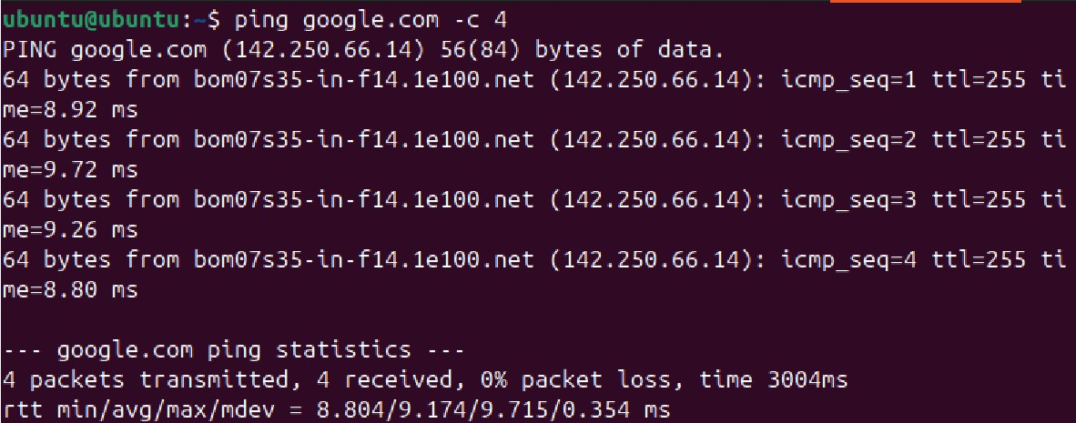
This ping command is used to check Network connectivity between our system and Remote server by sending packets. -c 4 indicates only four data’s will be show

- traceroute google.com :-
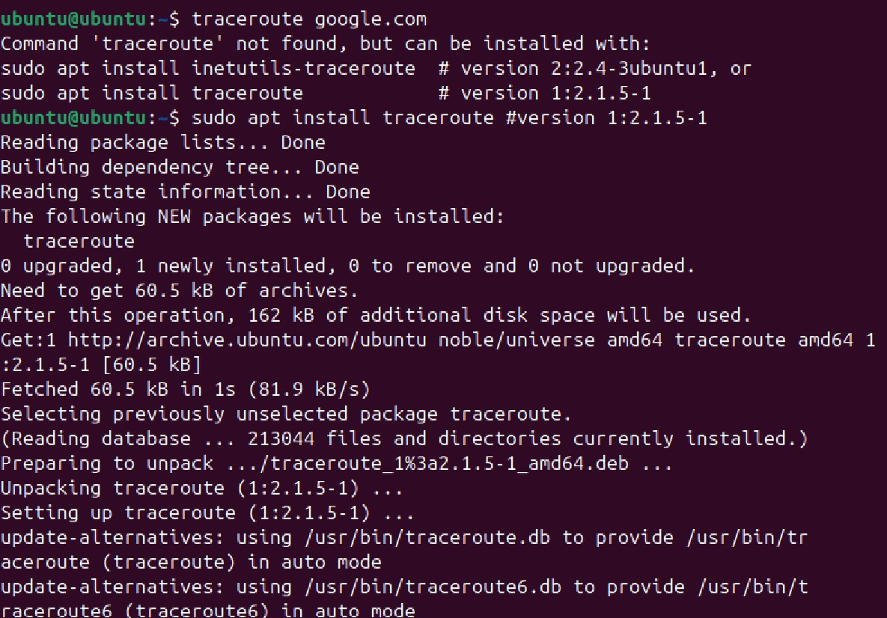
This command is particularly useful for network administrators to identify where the packets are being delayed or dropped. It is essential for troubleshooting connectivity issue, latency problems and routing failures.

- nslookup google.com: -

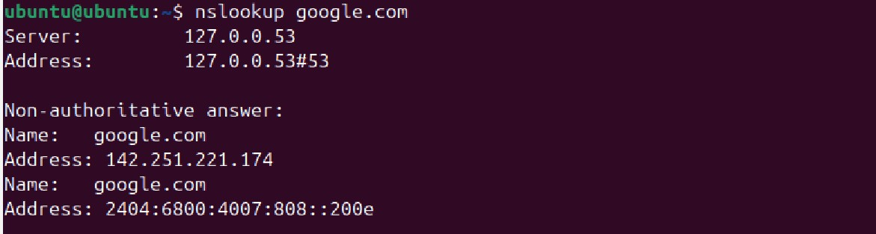
This command is used to query DNS to obtain domain name or IP address mapping. It clearly shows the name and Address of the domain.

- netstat -tulnp :-
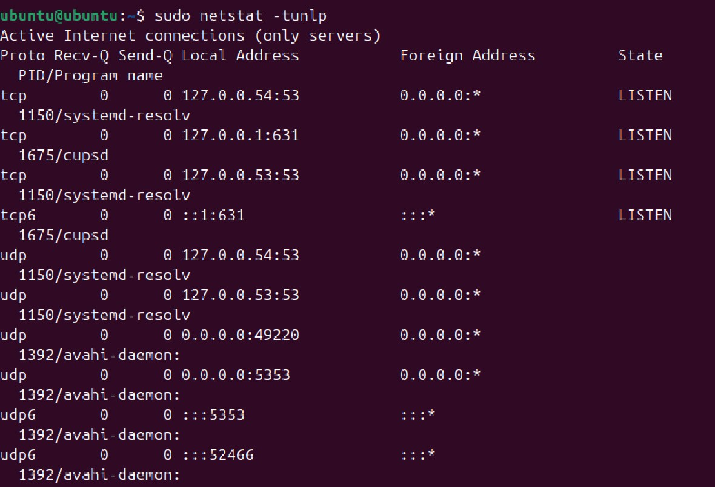
This command displays network connection, port availability, TCP process usage, UDP process usage, Numerical number(IP), Listening sockets and Process ID.

- curl ifconfig.me:-
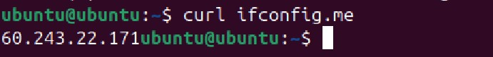
This command is used to allows users to view and change the parameters of the network interfaces such as IP addresses, netmasks and broadcast addresses.

